1. Brainstorma och hämta inspiration
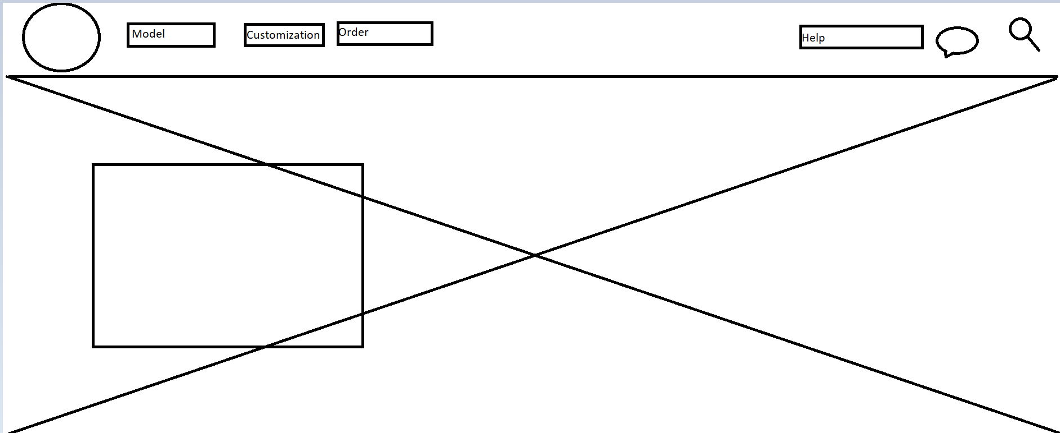
This is how I want my home page to look. I want it to be simple. I took inspiration from a lot of car websites since that's what I am going to work on. I am very passionate about cars and making a website relating to them would be super interesting. (This is a mindmap on paint)

Good and bad things about the websites for inspiration
Pros:
- Very simple design.
- Modern looks.
- Good colour combinations.
- The layout itself
Cons:
- Not much I can say since they are professional and there is no room for error.

The best thing that I can take is the layout and how simple it is.

2. Skapa en projektplan! (Word)
Börja med att skriva ner dina idéer kring den hemsida som du ska bygga. Utgå från följande rubriker
och frågeställningar.
Beskrivning av projektet:
- Vad är det för typ av hemsida du ska skapa?
- I want to make a website related to cars.
- Vad är syftet med hemsidan? Vad ska den användas till?
- I want to sell cars on my website.
Målgrupp:
- Vad har din målgrupp för förväntningar när de besöker din sida? (Tänk vanliga konventioner, dvs. Hur ”brukar det se ut” på liknande sidor, var placerar man exempelvis logga, meny, text, bilder etc.)
- I want anyone scrolling through my website since I want to develop an interest in those who aren’t car lovers.

- Vilken är din målgrupp? Vilka ska besöka sidan?
- As I previously said I want anyone who can
Gränssnittet
- Beskriv med ord vad som ska finnas med på sidan samt hur du tänker dig att det ska presenteras visuellt.
- I want it to be sleek and simple. It should look like a regular modern webpage.
- Hur kommer din design, layout och innehåll anpassas efter målgruppen?
- My design should be modern and well-placed. I want to make it easy to use and get a hang of it.
Lagar och etik
- Vilka lagar och etiska regler kommer du att behöva ta hänsyn till när du skapar och publicerar din hemsida och HUR tar du hänsyn till dessa?
- Probably images which I use. Since I am going to take them off online. So I will probably after selecting the images do research if I could use those images to not get copyrighted.
Punktlista
- Gör en punktlista med saker som ska göras. En steg-för-steg-beskrivning av din arbetsprocess.
- First design the layout on PS.
- Then design the link's website layout on PS as well.
- Then on visual code start writing the code in HTML and CSS.
- First design the background following my design on PS.
- Secondly, then design the links and add the link pages behind them.
- Thirdly, add stuff on my link pages.
- Lastly, add the final touches to finish my project.
3. Gör en wireframe (Photoshop)
När du har klart för dig vad det är för en hemsida som du ska bygga och vad du vill ha med på den är det dags att börja skissa på designen. Börja med en wireframe för att snabbt kunna bygga upp och få en överblick av den grundläggande layouten.
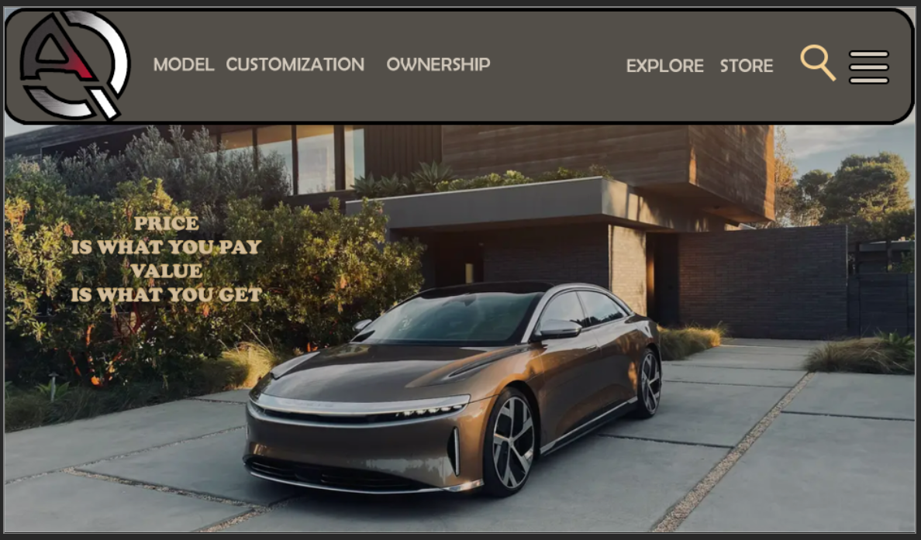

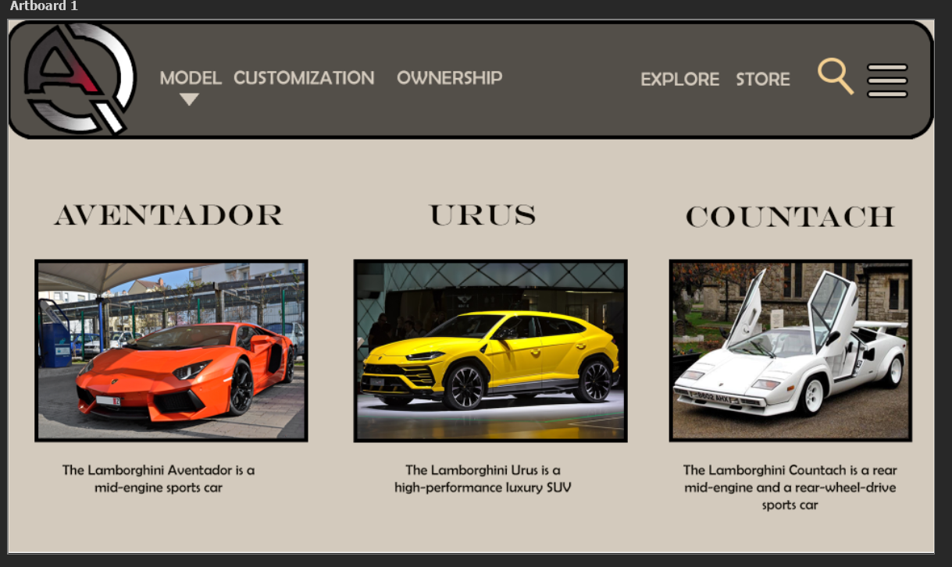

Something like this is not 100% but I mostly like this layout.

- Write the work process from idea to finished prototype. How did you go about it?
Firstly, I made a pre-planning on how I will work. Then I wrote down the ideas I thought of. Thereafter I made a wireframe in Photoshop to help get the ideas right. I also wrote a full document of all the documentation for example pros and cons etc. Then I also brainstromed ideas as to how my website will look and took inspiration from the Lamborghini site.
Secondly, I started coding and it took about 2 weeks of actual effort. Then I started by making the homepage first, then the model page, then the shop side and lastly contact side. All with similar code maybe a few details are not there.
- Did you run into any problems along the way? Which? How did you solve these?
Yes, because there was some point where I needed to use google and spend time to solve the problem for example how to inline texts or pictures. The biggest problem was the Shop link on my webpage. There are still some issues with the size but mostly it's okay. I took help from the internet and I spent time just trying different tries to figure it out.
- How did you concretely adapt the website to your target group? (Be as detailed as
possible here)
Just trying to get the sizes right and the distance of the contents. Maybe use the same font and colours to match my idea. I used photoshop to get the colour Hexa code right. Then figuring out the correct fonts. The positions really were difficult but it took some measurements to get them right.
- Which laws/regulations did you take into account in the work? How is this reflected in your content? Did you become
limited by this?
Yes, copy the right claim on photos so instead, I used Unsplash and played it safe by not taking any risks.
- Are you satisfied with the result? Why/why not?
Yes, I am satisfied but maybe a bit more work on the shop page or maybe a bit more knowledge is required for that. But overall I worked more than I taught and did more work. I surpassed my expectations and didn't know I could build it that well.
Improvement suggestions! (Develop the answer!)
- If you were to do a similar project again, what do you think should be considered? Tips for yourself?
1. Spend more time planning to make it more detailed.
2. Enjoy more rather than take the stress.
3. Learn more new tools in VS code.
-Are there any pitfalls that can easily be avoided?
No, I don't think so. But maybe read through your code or when going live always be on the HTML side.
- Do you have any advice on strategy in terms of planning and implementation?
Just be creative and calm while writing since you can always go back and change later on if needed.
- Did you need to broaden your knowledge in html and CSS to be able to build the page you wanted
den?
No not really I believe I got most of the stuff done and maybe a bit more practice could have helped.
- Other thoughts and reflections.
Not really, just enjoyed this and would like to do more of these projects in the future.

Home Page
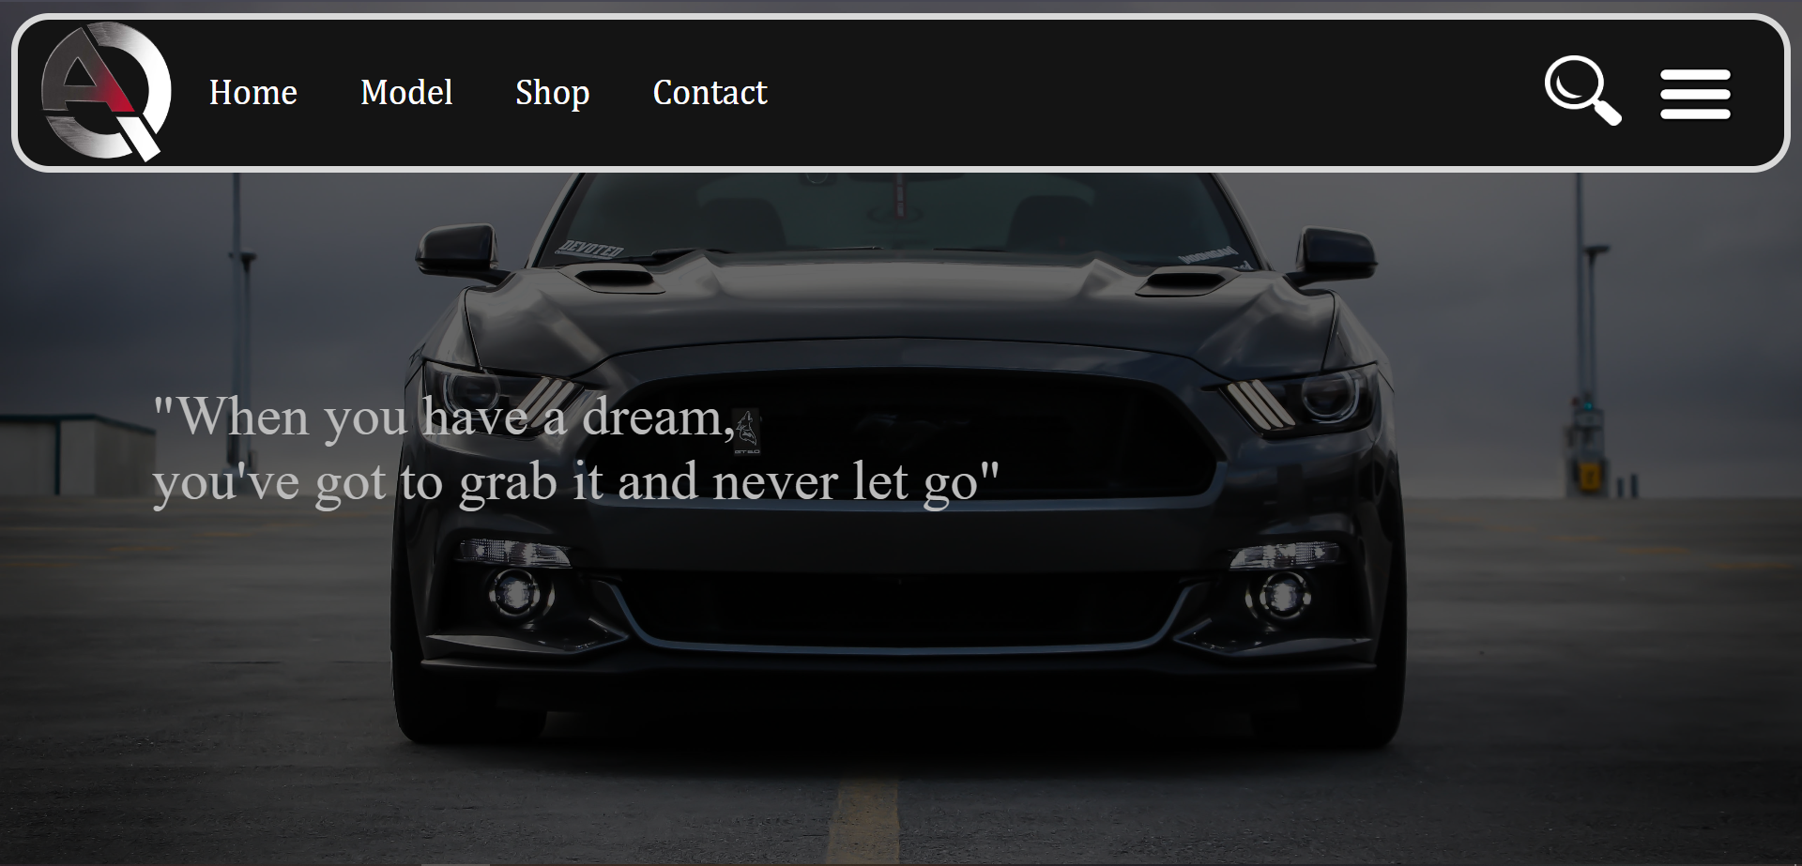

Model Page
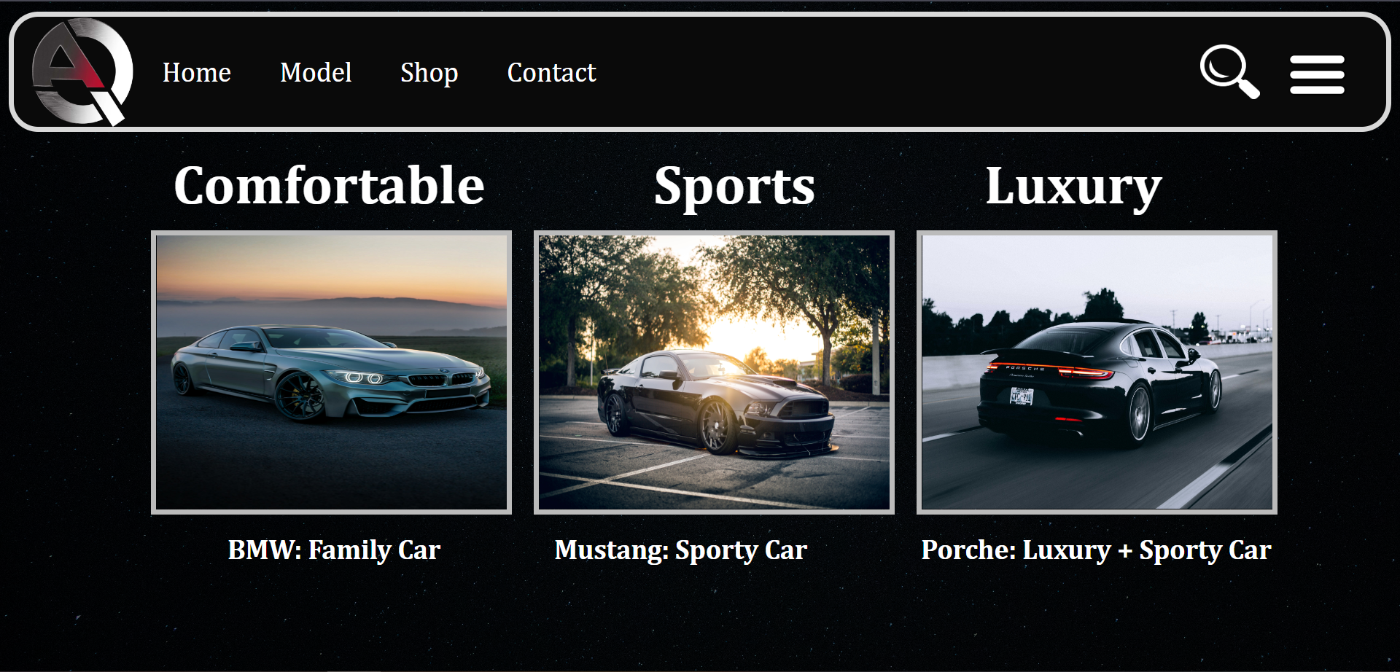

Shop Page
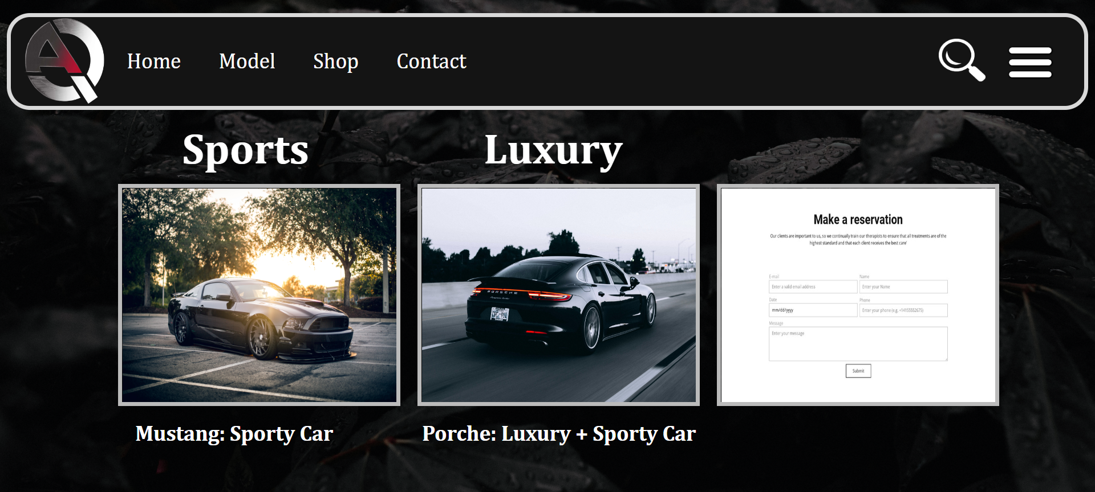

Contact Page
